**Excel Assignment - 11**

**1. Find the Minimum Marks and Maximum marks scored by each student.**

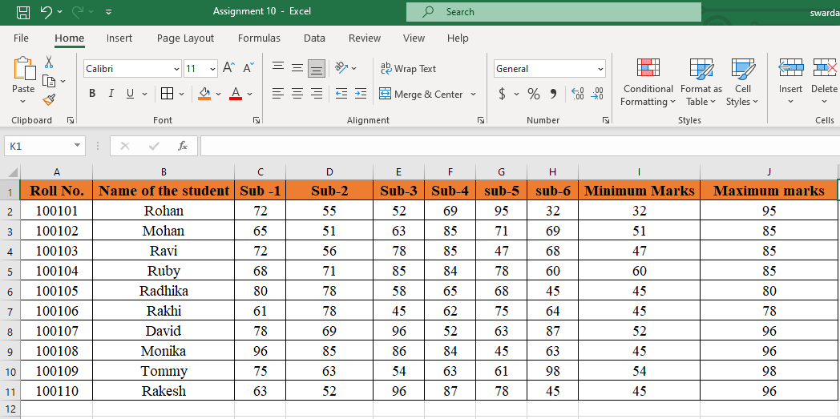

**2. Calculate the totals for each student, use conditional formatting to highlight the top students who have scored more than 480.**

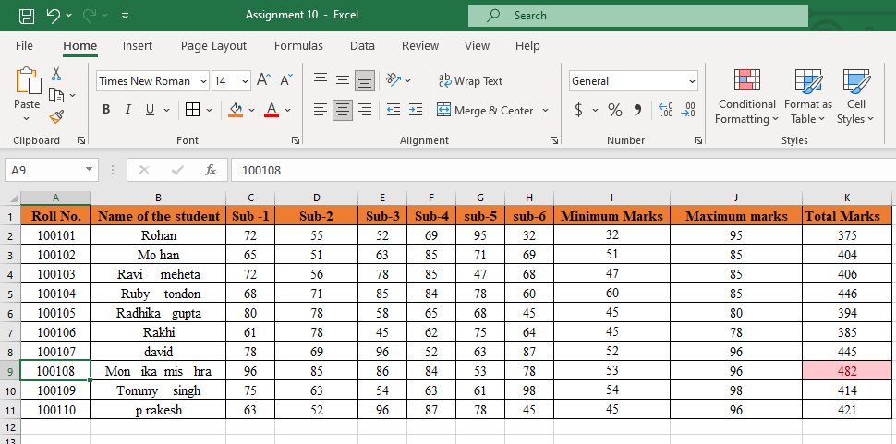

Note: the total sum was not greater that 480 so I changed some values for the output.

**3. Calculate the length of the names of each student.**

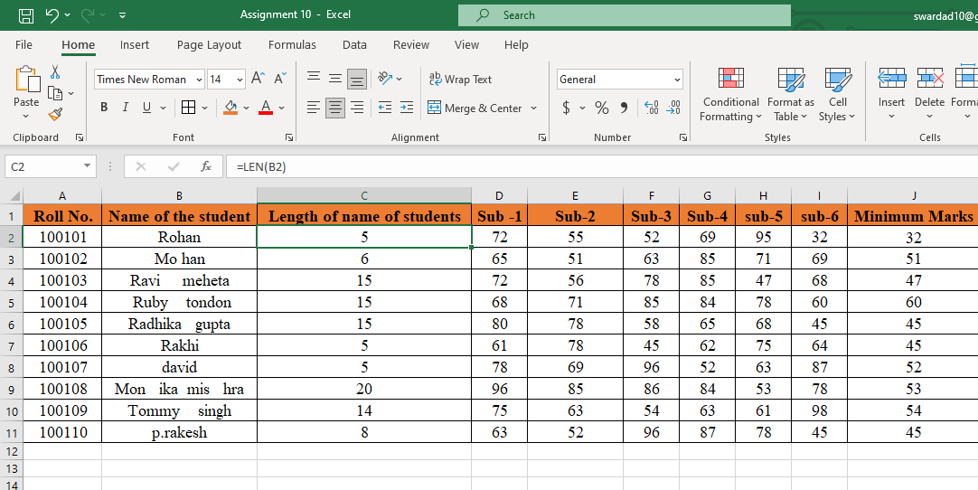

**4. Replace the Name Rakhi with Rocky. Use Formulas**

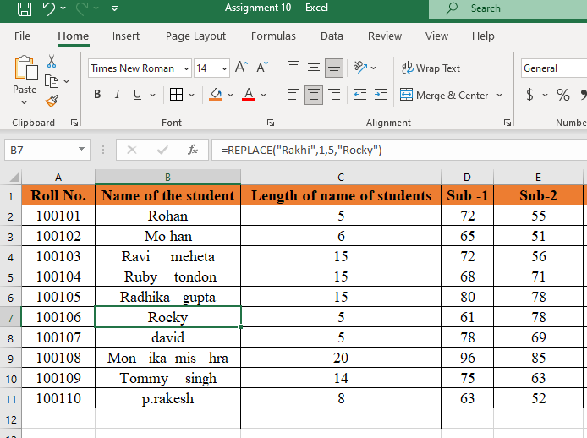

**5. Combine the Roll Numbers and Names. Use formulas. The end result should look like below.**

**100101Rohan**

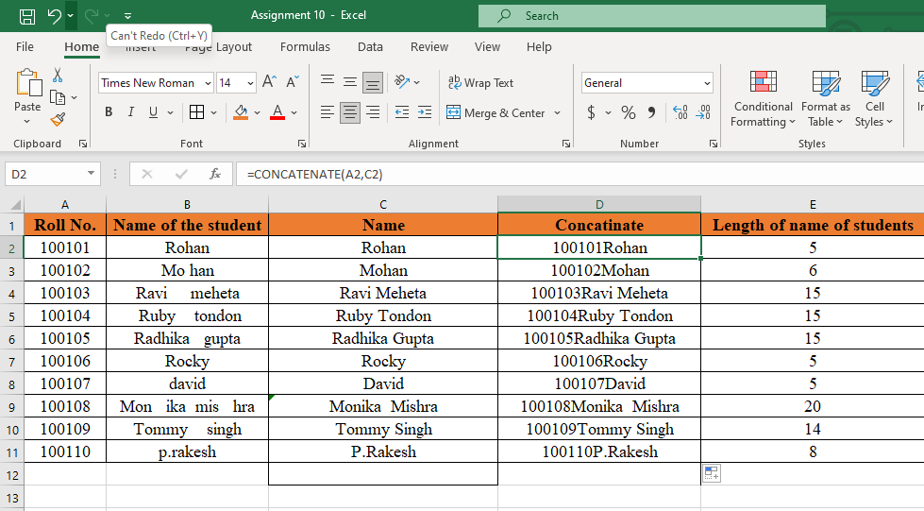

**6. As you can see that some names have spacing issues. Use Formulas to correct that spacing. Also ensure that the names and surnames start with a capital letter**

